

Sustainability Plan

Sustainability

Author:
P2, University of Jordan

February 2018

FOODQA - FOSTERING ACADEMIA-INDUSTRY COLLABORATION


IN FOOD SAFETY AND QUALITY
574010-EPP-1-2016-1-JO-EPPKA2-CBHE-JP

Document Template [Sustainability]

Document Data
Deliverable: Sustainability Plan
Work Package No & Title: Project Sustainability
Work Package Leader: P2- UJ (Jordan)
Partners involved: All
Distribution level: Partnership
Reviewed by: Fahmi (JUST), Riyadh (HTWK), Penelope (MONOJO), Tahat (JU), Tareq (BAU)
Document Version: 02 Final
Status: Final
Document History

Version | Date | Author/Organization | Changes
Version 01 | Sept. 2017 | UJ | Minor language changes
Version 02 | Jan. 2018 | UJ
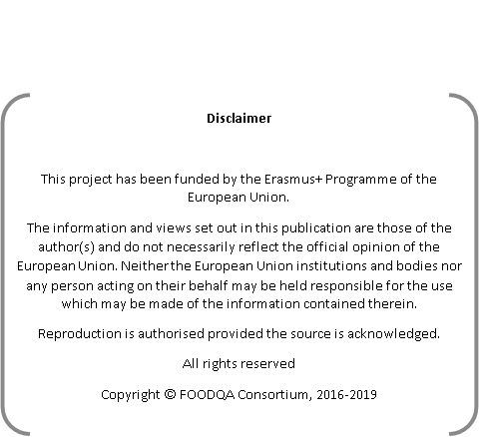

1 Deliverables

Sustainability of FOODQA project includes relevant deliverables, as follows:

- Sustainability committee
- Develop the FOODQA general sustainability plan
- Updating the related sustainability documents (PPTS, Reports) periodically.

2 Progress

2.1 Sustainability committee

Sustainability activities started an early stage of the FoodQA project lifecycle and will go on throughout its duration. The sustainability Committee was appointed at the FOODQA project’s meeting in Leipzig-Germany formed of one representative from each partner and Lead by University of Jordan. The committee is responsible to follow up with the project partners to sustain the operation of FoodQA center beyond the funding phase. The committee is responsible also to collect the information from the project partners about the structure of FoodQA center in each university in addition to the center activities such as training courses for local staff and stakeholders.

Sustainability have been discussed a in all 3 partnership meetings that have been organized so far, the relevant documentations were produced by UJ and uploaded to FOODQA project’s website.

2.2 Develop the FOODQA general sustainability plan

The version one of sustainability plan was drawn up in April, 2018 by the University of Jordan and discussed with the rest of FOODQA partners.

The sustainability is planned in this Joint Project has the aim of developing the competencies and the resources of the Jordanian universities in order to, by the end of the project; they will be in condition of having all the necessary competences and resources to ensure the sustainability of the Centres.

The Plan includes the following points in terms of sustainability:
- What is Project’s Sustainability?
- How to define a project’s sustainability in the field of Higher Education cooperation?
- Sustainable Project Vs Non Sustainable Project
- Financial Sustainability
- Sustainability Factors for FoodQA project.
- Establishment of FoodQA Center.
- Establishment of Sustainability Committee

- Ensuring Sustainability for FoodQA project
- Sustainability of FOODQA centers.



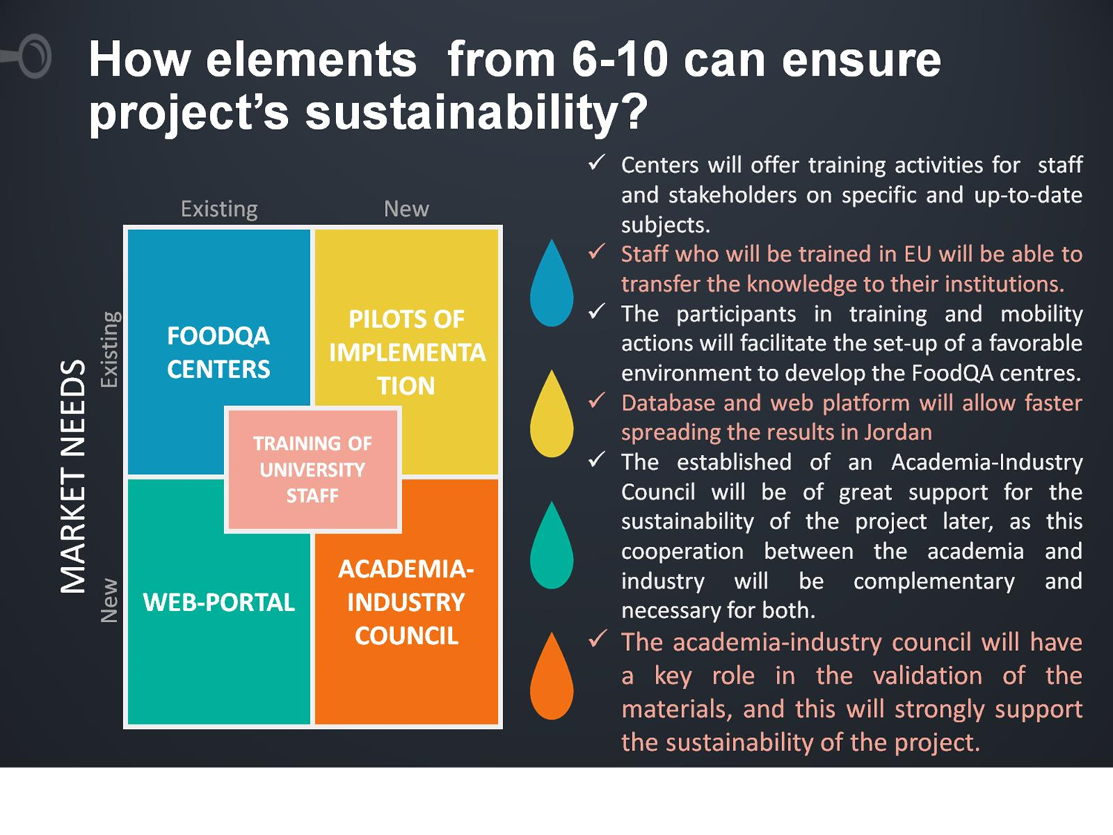
2.3 Sustainability of FOODQA Quality and Safety Centers:

Creating a sustainable campus strengthens the core research and teaching mission, and it acknowledges that the challenges before us are complex and interconnected, demanding an ever-developing approach to sustainability.
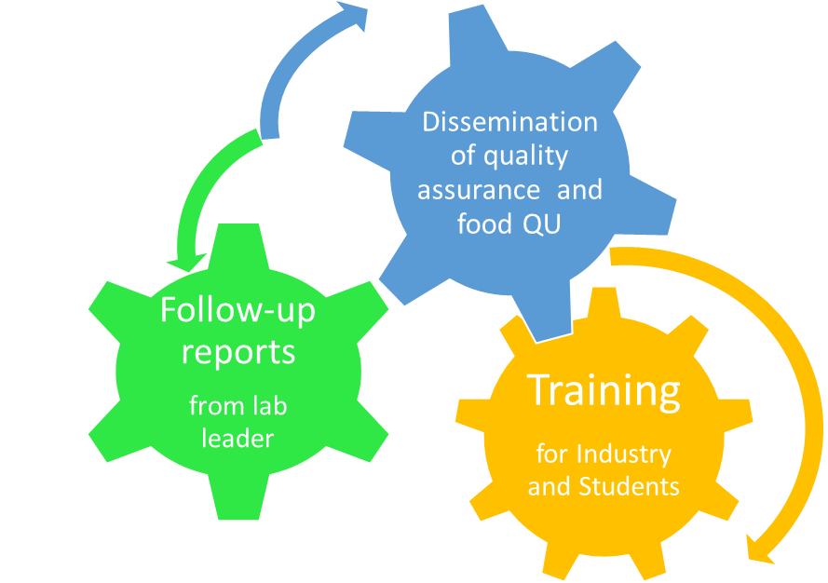

Document Template [Title of the Document]

2.4 Financial resources and financial sustainability

Financial resources for specialized consultations and other R&D activities will be secured from various sources inside and outside the university.
Those may include but not limited to: deanship of scientific research, higher council of science and technology, scientific research fund at the Mistry of higher education and scientific research as well as many other funding agency.

2.5 Institutional support and infrastructure

The Food Safety and Quality center will be administered by the department of Nutrition and Food Technology, Faculty of Agriculture at each Jo-partner University.
The center will have access to several laboratories and research centers at the university, including but not limited

- Dept. of Nutrition and Food Technology labs
- Pilot plant at the Faculty of Agriculture
- Unit operations pilot plant at Chemical Engineering dept.
- University central analysis labs
- Pharmaceutical Research Center
- Nanotechnology institute

